**The Labeler Instruction Manual**

**Step 1:**

**Open Command Prompt.**

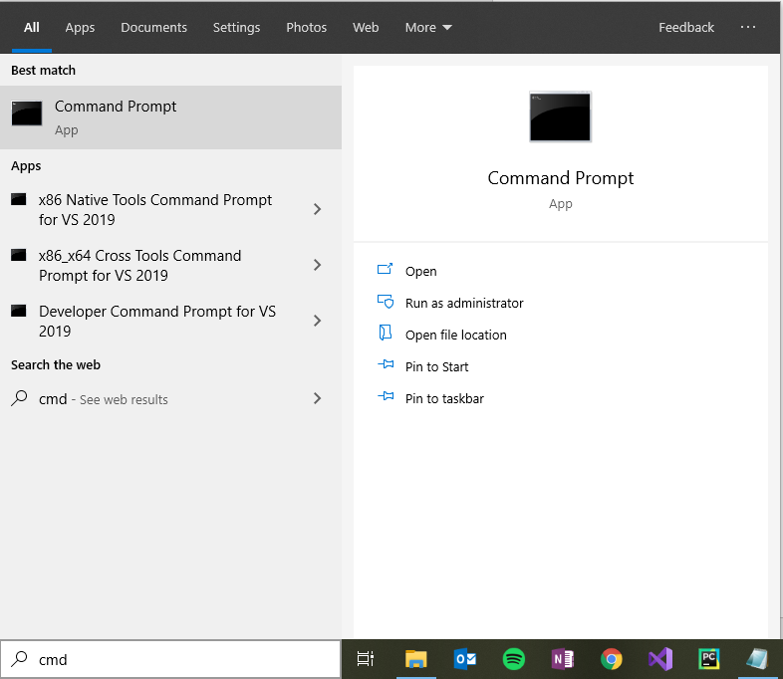

**It should look something like this when open:**

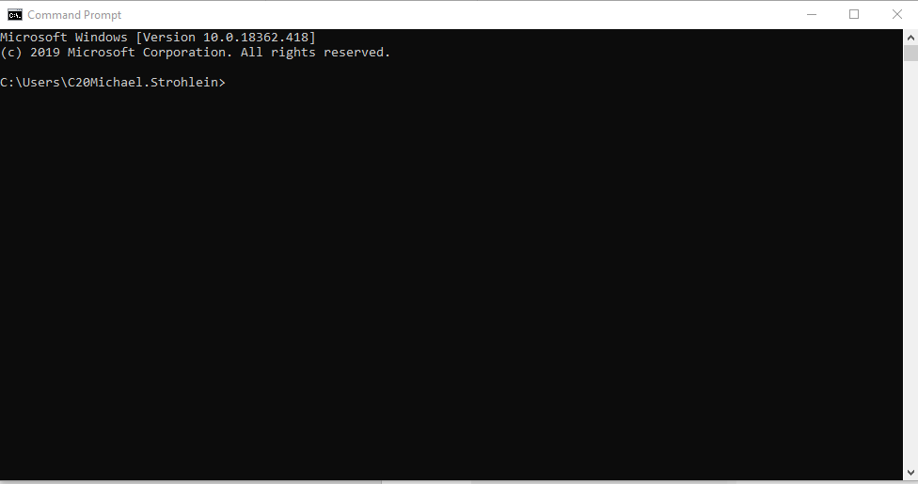

**Step 2:**

**type: "cd (path to file)"**

**path to file = copy the path to the folder that holds the python script**

**example:**

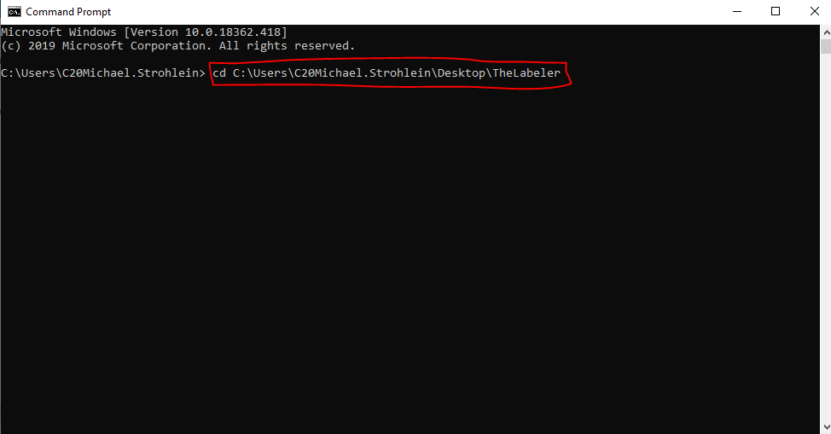

**Step 3:**

**Press Enter.**

**Step 4:**

**Type the name of the python script:**

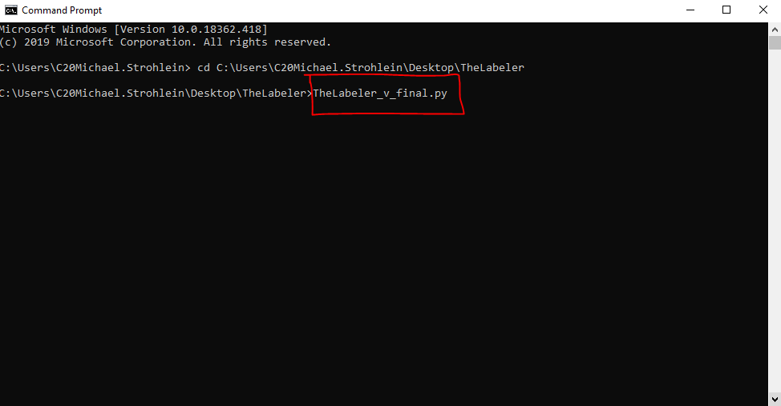

**Step 5:**

**Type the mode number you want:**

**Mode 1 = Full interface display --> "TheLabeler_v_final.py 1"**

**Example Mode 1:**

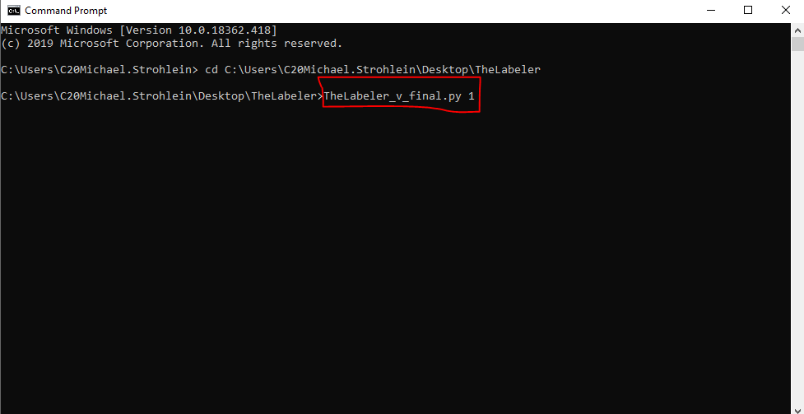

**Mode 2 = Only interface progress display --> requires additional input("TheLabeler_v_final.py 2 PRF.csv FLT.csv ErrorCodes.csv")**

**Example Mode 2:**

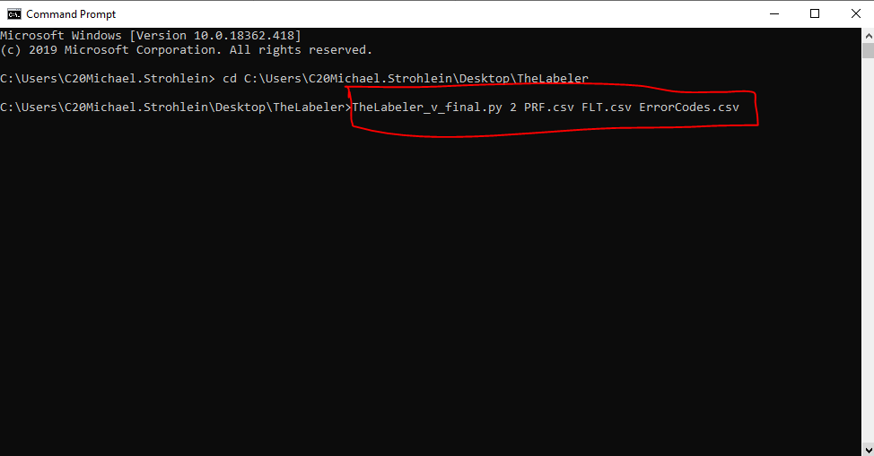

**Mode 3 = No interface display --> requires additional input("TheLabeler_v_final.py 3 PRF.csv FLT.csv ErrorCodes.csv")**

**Example Mode 3:**

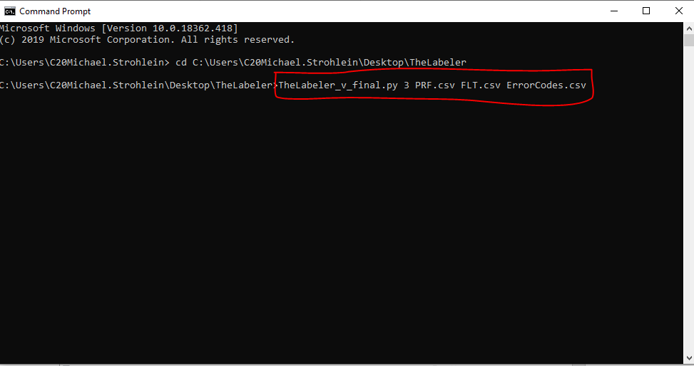

**Mode 4 = Only file selection interface --> "TheLabeler_v_final.py 4"**

**Example Mode 4:**

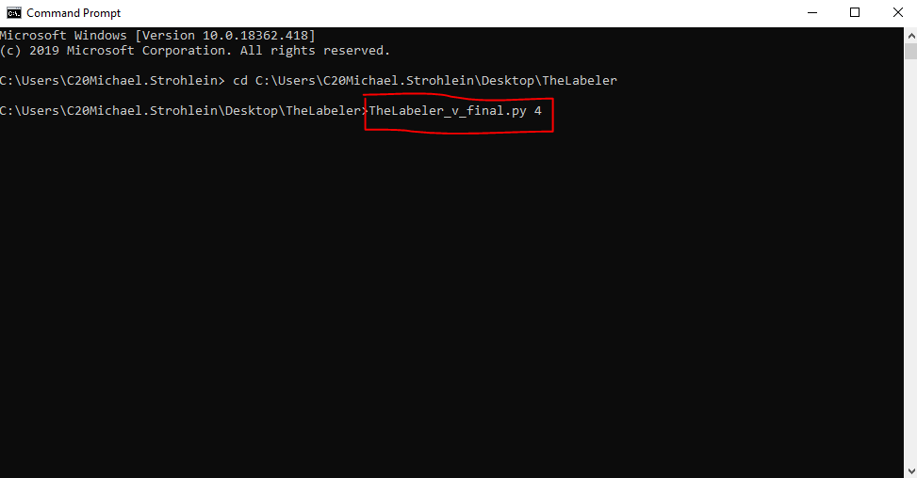

**Step 6:**

**Press Enter.**

**Additional Notes:**

File Choser Instructions:

You can type in the name of the file in the respective field. (if not in the same folder as the python script this requires full path) :

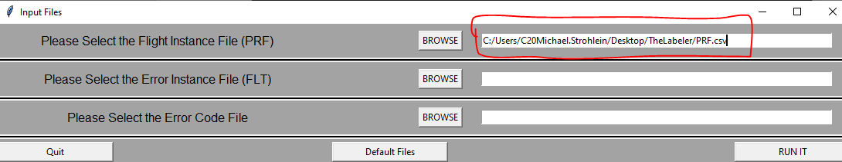

You can use the browse button to select the file from the file choser and it will auto populate the entry field with what you selected

You can use the default button which auto populates fields with file names. (Assumes File names are: PRF.csv, FLT.csv, ErrorCodes.csv and are stored in the same folder as the python script)

Progress Interface Instructions:

To quit at any time press: CTRL + C (when clicked into the command window)

Once the program is finished running:

You can exit the program using the exit button

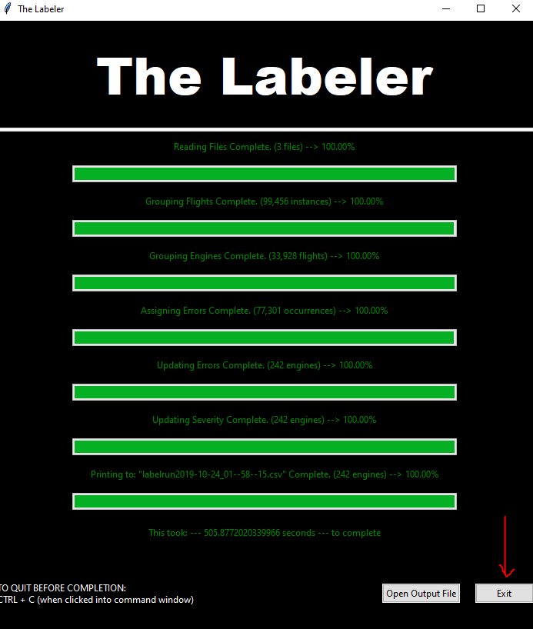

You can open the output file. (If you select this you will need to exit the program by using the exit button to end the run of the program)

